Editing DBDocs

First off, set up an entry to connect to the server, localhost is the default
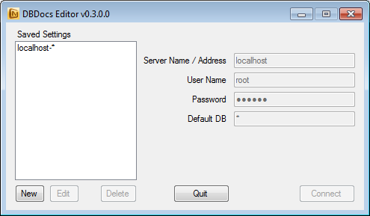

Once connected to the server, select the database to look at
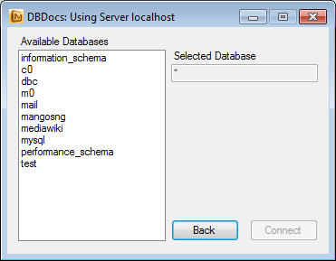

On the left a list of all the tables is displayed
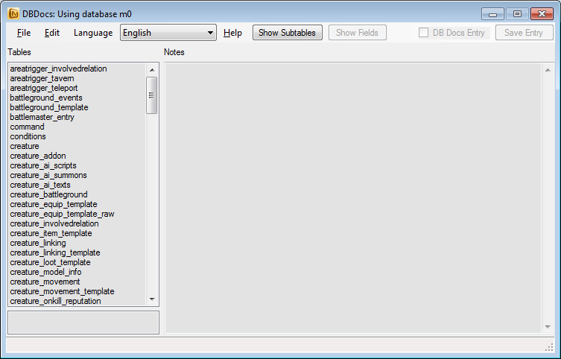

Clicking on the table will display the table notes in the selected language. Click on ‘Show Fields’ to open the field list. “Show Subtables” will show all the defined subtables.
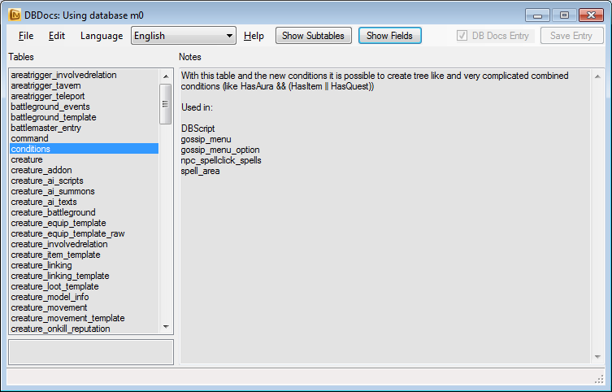

Much like before, click on the left panel to display the field notes. In the example below there is also a subtable entry. Whenever a subtable is detected, the bottom left panel will show a link to the subtable. “Show Subtables” will show all the defined subtables. “Insert Subtable” will allow you to add a subtable.
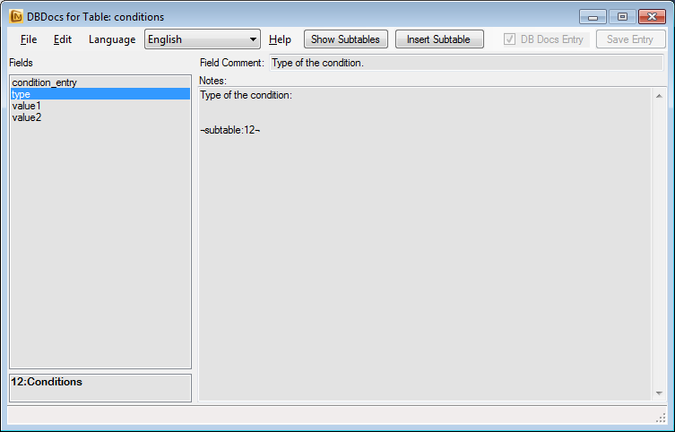

Clicking on the subtable (In this case “12: Conditions”, the data is shown)
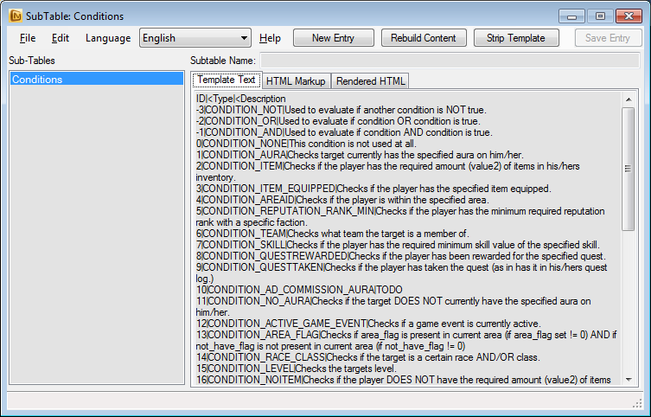
Click on the Rendered HTML table will give you a simple HTML render of how the subtable will look like.
